**1. Find all customer related information who have an account in a branch, located in the same city as where they live. (write this query without using subqueries and then using a subquery) Using Subqueries:**

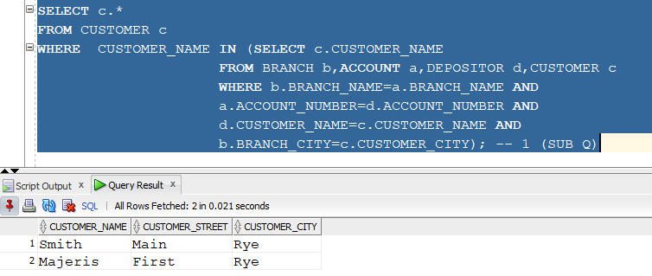

**Without Using Subqueries:**

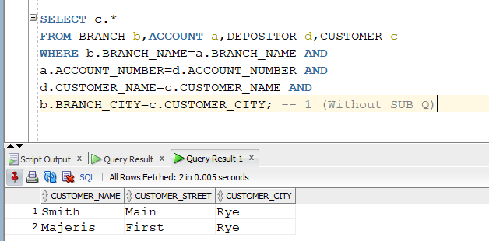

**2. Find all customer related information who have a loan in a branch, located in the same city as where they live. (write this query without using subqueries and then using a subquery)**

**Using Subqueries:**

**Without Using Subqueries:**

**3.** **For each branch city, find the average balance of all the accounts opened in a branch located in that branch city. Do not include any branch city in the result where the total balance of all accounts opened in a branch located in that city is less than 1000. (Write this query with and without using ‘having’ clause)**

**WITH HAVING:**

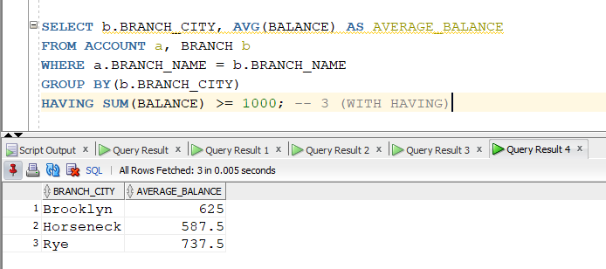

**WITHOUT HAVING:**

**4. For each branch city, find the average amount of all the loans opened in a branch located in that branch city. Do not include any branch city in the result where the average amount of all loans opened in a branch located in that city is less than 1500. (write this query with and without using ‘having’ clause)**

**WITH HAVING:**

**WITHOUT HAVING:**

**5. Find the customer name, customer street, customer city of the account which has the highest balance among all the accounts. (Write this query with and without using all keyword)**

**With ALL:**

**Without ALL:**

**6. Find the customer name, customer street, customer city of the loan which has the lowest amount among all the loans. (write this query with and without using all keyword)**

**With ALL:**

**Without ALL:**

**7. Find the distinct branches (name and city) that have opened both accounts and loans. (Write this query using in and exists keyword)**

**Using IN:**

**Using Exists:**

**8. Find the distinct customers (name and city) who do not have loans but have accounts. (write this query using not in and not exists keyword)**

**Using NOT IN:**

**Using NOT EXISTS:**

**9. Find those branch names which have total account balance greater than the average of total balance among all the branches. (write this query with and without using with clause)**

**Using WITH CLAUSE:**

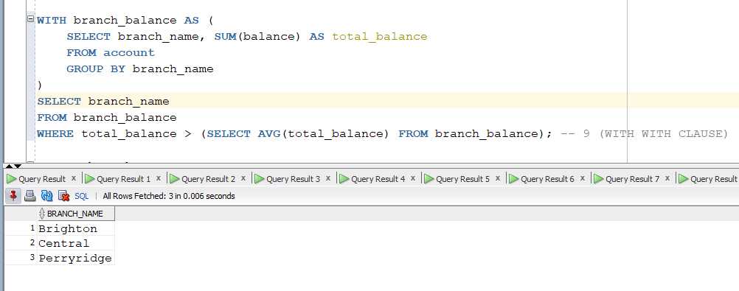

**Without Using WITH CLAUSE:**

**10. Find those branch names which have a total loan amount less than the average of the total loan amount among all the branches. (write this query with and without using with clause)**

**Using WITH CLAUSE:**

**Without Using WITH CLAUSE:**

